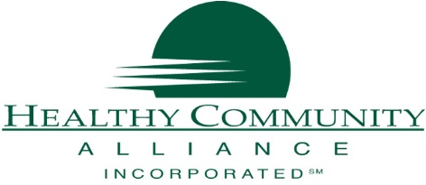
Healthy Community Alliance
1 School Street, Suite 100
Gowanda, NY 14070
CONTACT: Mallory Eddy, Program Assistant
eddym@hcanetwork.org | (716) 532-1010

FOR IMMEDIATE RELEASE
New Program Launches to Support Rural Caregivers
August 1, 2021 GOWANDA, NY - Healthy Community Alliance and partners in Cattaraugus and Wyoming counties will begin the implementation phase of the pilot project, Caregiver Tech Solutions, that will focus on how physical and digital technology can be used to help WNY rural caregivers achieve a sense of relief, learn self-care techniques, and solve new problems in caregiving.
As the population continues to age, millions of older Americans will require assistance of some kind and many will rely on help from a spouse, daughter, son, grandchild or friend for care. Caregiver Tech Solutions provides access to technology resources, as well as some basic technology equipment, which will support a caregiver in the complex responsibilities of caregiving for an older adult or loved one.
Since every caregiver has unique challenges, Caregiver Tech Solutions will also provide one-on-one coaching support to explore and customize a technology solution for a personalized caregiver journey for caregivers in Cattaraugus and Wyoming Counties. The program supports caregivers through:
- One-on-one virtual or telephonic workshop sessions with a trained coach
- Free technology solutions (equipment and digital content at no cost to the caregiver)
- Information Technology Help Desk support upon request
- Robust website www.caregivertechsolutions.org for relevant and easy to understand information about technology solutions that caregivers can access at their own pace.
To learn more about how Caregivers Tech Solutions can enrich your caregiver journey or support someone else who may be caring for another, call Healthy Community Alliance at (716) 532-1010. For all of the latest information, please visit www.caregivertechsolutions.org
About the Communities Care Family Caregivers Respite Pilot Program

The Communities Care Family Caregivers Respite Pilot Program is funded by the Ralph C. Wilson, Jr. Foundation (RCWJRF) and the Health Foundation for Western & Central New York (HFWCNY), and managed by The Philanthropic Initiative.

Healthy Community Alliance, Inc., located in Gowanda, NY, is a Rural Health Network and is the CBO Consortium of Upstate NY Lead Agency. The mission of Healthy Community Alliance is to improve the quality of life in rural communities through broad-based, inclusive partnerships that support wellness and prevention. www.communityalliance.org

