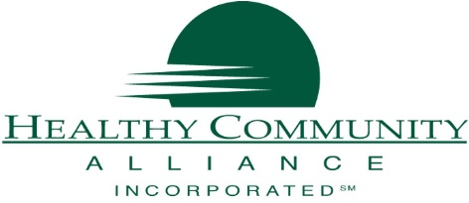
Healthy Community Alliance
1 School Street, Suite 100
Gowanda, NY 14070
CONTACT: Mallory Eddy, Program Assistant
eddym@hcanetwork.org | (716) 532-1010

FOR IMMEDIATE RELEASE
HCA Receives Grant to Support Family Caregivers
August 17, 2020 GOWANDA, NY - Healthy Community Alliance and partners in Cattaraugus and Wyoming received a grant from the Communities Care Family Caregivers Respite Pilot Program that will support innovative solutions for caregiver respite. The project, called Western New York E-Respite, will focus on how digital technology can be used to help WNY rural caregivers achieve a sense of relief, learn self-care techniques, and solve new problems in caregiving.
While respite has traditionally been a placed-based service, this grant will focus on what caregivers can implement or modify within their homes using technology to be able to have relief from a task while maintaining care for their loved one and also supporting self-care for themselves. This is important for rural caregivers who often do not have access to traditional place-based respite or affordable forms of secondary caregivers. Through individualized respite coaching and digital technology resources, respite will be re-imagined and caregivers will be able to have relief from some responsibilities. Amidst the COVID-19 pandemic, which halted traditional, place-based respite, this solution will help caregivers create opportunities for much needed breaks from caregiving using digital technology. The funding will support information sharing with health insurer partners who seek to explore the impact of respite on family caregivers and potential benefit designs or other strategies through which they might support caregiver respite.
About the Communities Care Family Caregivers Respite Pilot Program

The Communities Care Family Caregivers Respite Pilot Program is funded by the Ralph C. Wilson Jr. Foundation (RCWJRF) and the Health Foundation for Western & Central New York (HFWCNY), and managed by The Philanthropic Initiative (TPI) with support from Teresa Lawrence of International Deliverables. The program is funding innovative, collaborative projects that aim to increase respite opportunities for family caregivers of older adults in rural Western New York and beyond. Respite, a period of rest or relief, can play a key role in reinforcing caregiver well-being and effectiveness, and improved caregiver well-being can be linked to better health, social-emotional outcomes and lower costs of care for family caregivers (and for older adults they care for).

The funded projects emerged from an initial learning phase in 2019 and early 2020 which brought teams of organizations together to apply Creative Problem Solving techniques and identify new strategies for supporting family caregivers. In addition to these grants, a learning community among the funded project teams will facilitate idea generation, relationship development and shared learning.

“Family caregivers play an essential role in the lives of older adults in our communities, and deserve support and recognition for their invaluable work,” said Ken Genewick, Program Officer for Caregiving, HFWCNY. “We are proud to partner on this initiative with the Ralph C. Wilson, Jr. Foundation with the goal of enabling organizations to team together and develop creative respite programs that provide a new level of support for our communities’ caregivers.”

Healthy Community Alliance, Inc., located in Gowanda, NY, is a Rural Health Network and is the CBO Consortium of Upstate NY Lead Agency. The mission of Healthy Community Alliance is to improve the quality of life in rural communities through broad-based, inclusive partnerships that support wellness and prevention. www.communityalliance.org

